Installation is done

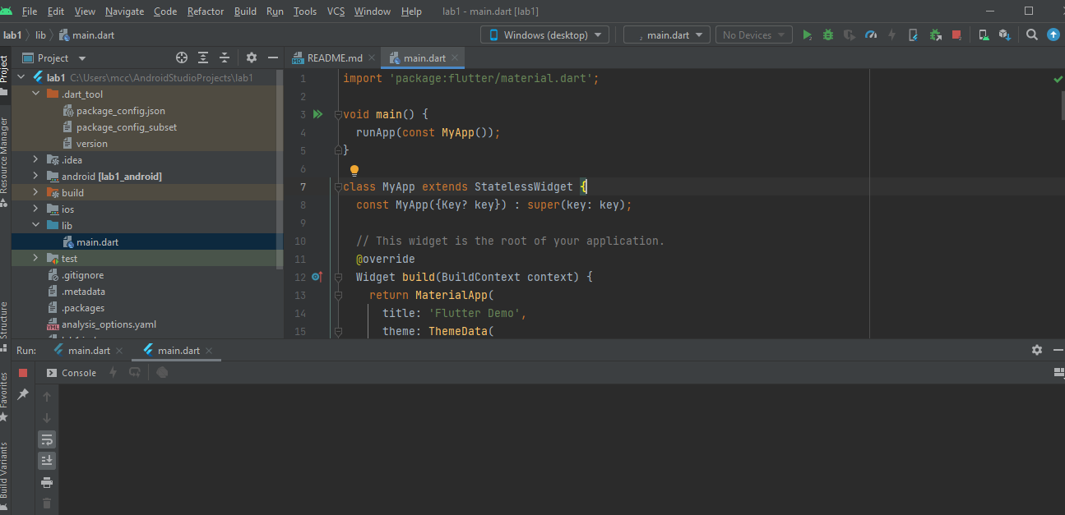

Create Class on Dartpad for system of your faculty with minimum 3 attributes and constructor

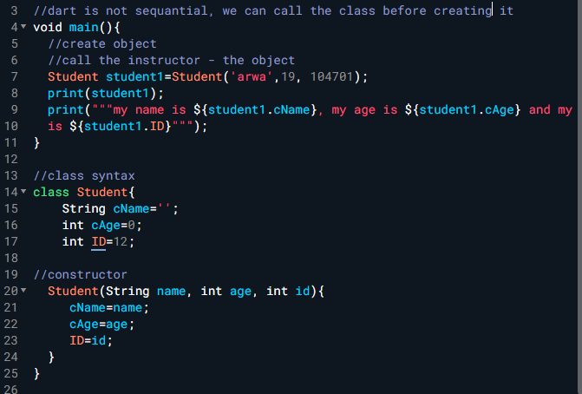

What are “Types”?

A- Data types of values you work with your code.

B- the name types of variables in your code.

C- Function arguments used in your Code.

What is the job of “variables”?

A- Variables allow you to execute code whenever you want.

B- Variables describe the type of data you’re working with.

C- Variables hold data with which you can work in your code.

What are “functions”?

A- Functions can be instantiated to create objects.

B- Functions store data so that you can use it later.

C- Functions hold code which you can call as often and whenever you want.

What is a “property”?

A- a variable inside a class.

B- a function inside a class.

C- a class inside a variable.